COMP140 Individual Creative Computing Project Report

Proposal:

Game and Controller Idea:

My game idea is a 2D platformer, the level will be mostly bare and the player will randomly jump, run, walk and change direction. There will also be coins that the player could collect and obstacles, however, no platforms. By itself this game would be boring and pointless to play as there would be nothing for the user to do, however, when combined with my controller the game becomes a fun puzzle game. The controller will be a box split into 20 cube sized slots in a 2 x 10 arrangement, the player will be able to place cubes into said slots and in turn will start to create the platform for the character to move across. The user will have to put the cubes into the correct slots in order to successfully create platforms the will allow the character to get to the other side whilst avoiding obstacles and coins along the way.

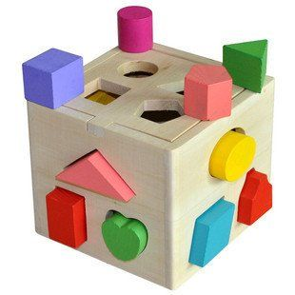Target Audience:

I have thought about the reasons why this controller and game would be good and also what type of person would use it. I will be aiming this concept at 6 – 10 year olds due to its simplistic nature but also its ability to let children of that age learn how to problem solve. I took my original idea from this childs game that most toddlers play, I have thought about this game and controller as a step on from this. By using blocks that fit into slots, this game should feel familiar to most children and in that aspect should be easy to grasp.

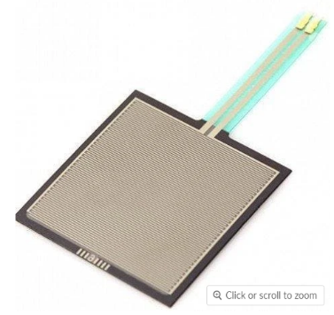Components:

In order to create this controller I will not need many components as all I will need to do is detect when the users places a cube into one of the slots. I have thought a lot about how I am going to achieve this and my finally conclusion is that I will have force sensitive resistors on the bottom of each slot that will register when an object is placed on top. These are the only additional components I will need in order to complete the controller other than the Arduino and wires to link everything up.

Hardware:

As first predicted in my proposal, the components I needed where very basic and no other components that weren’t outlined in my proposal were needed. The components that were needed for the project are as follows, 20 pressure sensitive variable resistors, 1 Arduino uno and an assortment of wires.

The pressure sensitive variable resistors are used to register when one of the cubes are dropped into the holes of the controller. Using the these resistors allows me to register when pressure is put onto it, which in turns allows me to make the relevant changes in the game itself. The Arduino uno is needed for obvious reasons of taking the inputs from the controller and translating it so I can use the inputs within the game. Last but not least is the wires which are there to make sure that all the resistors can communicate with the Arduino.

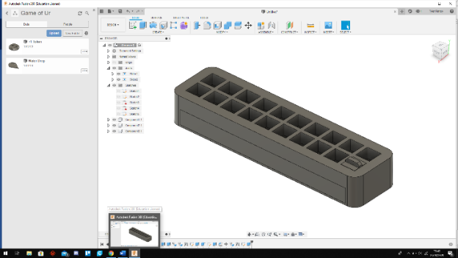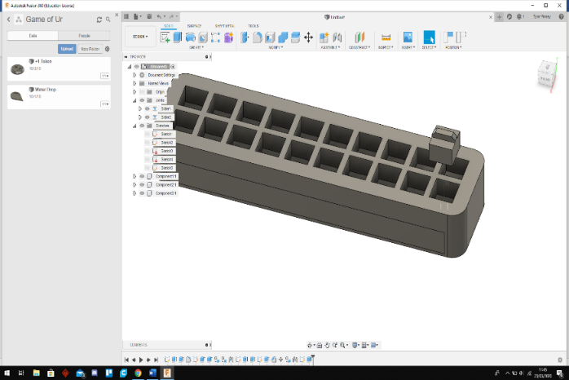Controller Design:

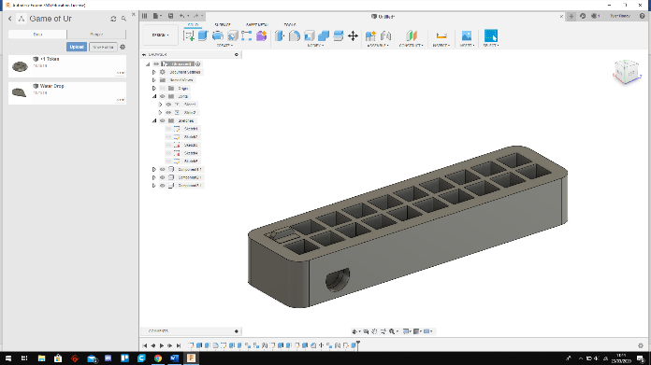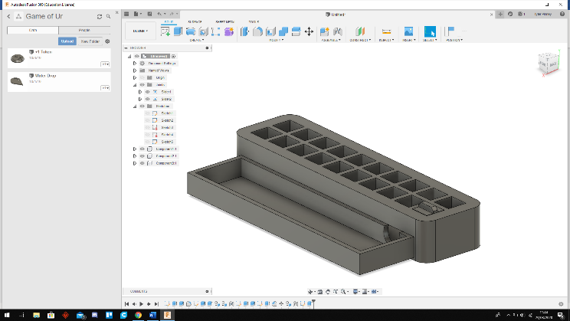In terms of the controller itself I have tried to keep it simple because of the age range that I am aiming for with this project. I have keep the design very minimalistic with not very much happening on the exterior. I have also rounded all the edges to make sure that there are no hazards to young children in that aspect. The controller consists of 3 main aspects, the holes for the cubes, the cubes themselves, and a drawer underneath.

The holes for the cubes are there for the cubes to be placed into when the user decides to, the resistors I am using to, register when the cube is placed in a hole, will sit at the bottom of these slots with small holes at the edges where the wire can come down into the drawer section. In this drawer section is where I will store the Arduino, it also has a hole coming out of the back of the controller so that I can have the power cord from the Arduino into the computer tuck away neatly. The cubes that the user will place into the controller are very simple, they are just basic cubes with a raised handle at the top so that the user can easily hold and manoeuvre them.

The Game Concept:

The game concept is simple, there is a character on screen who will ran forward and jump at random intervals, your job as the player is to place the blocks into the holes on the controller in order to create a platform for the character to get to the other side of the screen. The score on how well you did will be based of a level system, as you get to other side the game will reset but the character will become a little faster and this will be level 2, it will carry on like this indefinitely. If the character falls of the map 3 times then you lose the game and the score will be whatever level you successfully completed last. With in these levels there will also be randomly generated bombs and coins, the bombs will hurt the player and every 3 bombs will cause the player to lose a life. However, every 5 coins that you collect will add a life to the player, this make the game more interesting then just creating a pathway for the character to the other side.

Software Design:

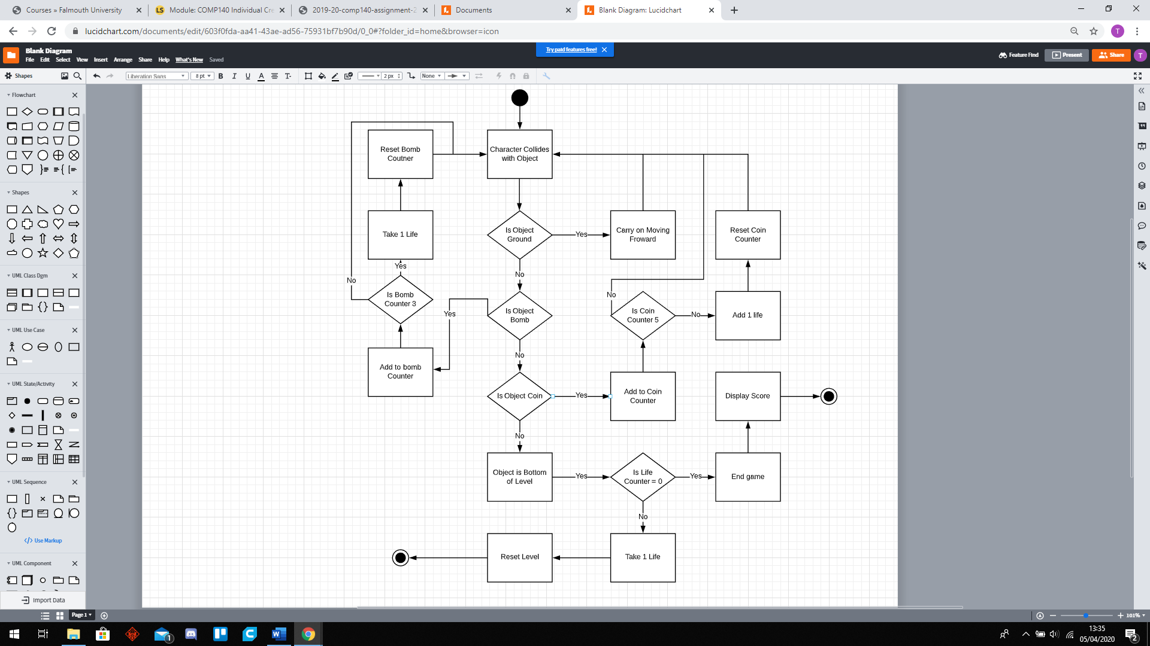

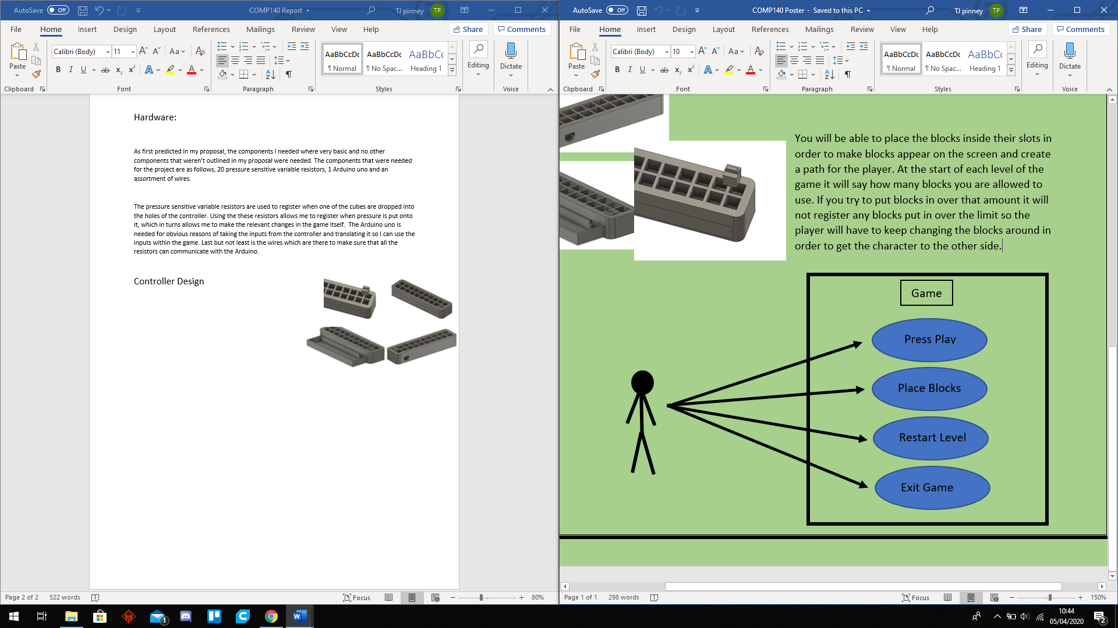For the software design I have laid out the basics of the game in an activity diagram as seen to the right. This diagram expressed what happens when the character collides with an object which is the whole basis that the game runs on. If the character did not collide with anything then my game would break. It demonstrates the 4 objects that the character will be able to collide with and what happens when they do. The first check is if the object that has been collided with is the ground, if it is then the character will continue moving forward and doing all his normal randomly generated actions. However, if it is not then we check if it is a bomb that the character collided with. If so then we add 1 to the bomb counter and then check to see if that counter if equivalent to 3. If it is then we take 1 life away from the character and reset the bomb counter back to 0, if it is not 3 then we go back to checking if the player has collided with anything. If the object is not the ground or a bomb then we check if it’s a coin. If so we do a similar process as the bomb, by adding 1 to the coin counter, if the coin counter is equal to 5 then we add a life and reset the counter. If not then we go back for checking of there is a collision. Last but not least if the collider is not ground, bomb or coin then it can only be the bottom of the level meaning the character has fallen out the level. In this case we will check the life counter and see if it is 0, if it is then we end the game and display the players score on screen. However if the life counter is not 0 then we can take 1 life and restart the level again.

Next is a case diagram which is very straight forward and highlights the actions that the player can take whilst in the game. He can start the game, place the blocks in the controller, restart the level or exit the game. Due to this game being aimed at a younger audience I didn’t want to overwhelm them with a lot of options that they can pick whilst in the game so I decided to keep the action the player can do simple and sparse.

Reflection:

In reflection of this project I personally feel that I have done well. I managed to keep the scope of the controller and game to a level where I could complete it on time. However, looking back at the project I feel as though I could have done a lot better with time management but with the state of life currently with Covid-19 going around it did put a hold on my project which I recovered from very well.

The project itself went very smoothly with little to no issues whilst coding the game. However the one challenge that did occur was learning about how to make a 2D game as I have only ever worked on 3D games in the past. I was also planning to make the game look a lot before final submission however with going home I did not have photoshop in order to create better visuals for the game.

In terms of the controller and the hardware side of the project, I found this very difficult and really struggled with learning how to wire everything up so that it would work correctly. I learnt a lot about tinker CAD and how the components work together with the Arduino.

All in all I would say that the project went well with only a few bumps along the way and I am happy with the end result.